# ASSESSMENT 1 (12 marks)

# *(1000-1500 words)*

# Team Report

## {{Team Name}}

*A report is of great importance in a business. As software engineers we need to use reports to model high level technical specifications and design aspects of the software solution so stakeholders can understand how the software will be developed and what is required.*

## Stakeholder Analysis –1

## A stakeholder analysis is a process of identifying people involved with the project before the project begins; grouping them according to their levels of participation, interest, and influence in the project; and determining how best to involve and communicate each of these stakeholder groups throughout.

## Release Backlog - Andie

The goal of a given release is to deliver a subset of the product backlog, known as the releasebacklog. After identifying which user stories will go into a particular release, the user stories become part of a releasebacklog.

## Release & Iteration Plan - Andie

For the release and Iteration plan The team pulls the stories into the sprint backlog from the product backlog and groups them into independent tasks of fewer 8 hours each. From doing this the team should have a detailed map of which user stories will be completed in which sprint.

**Use Case Model - Zhihao Xing**

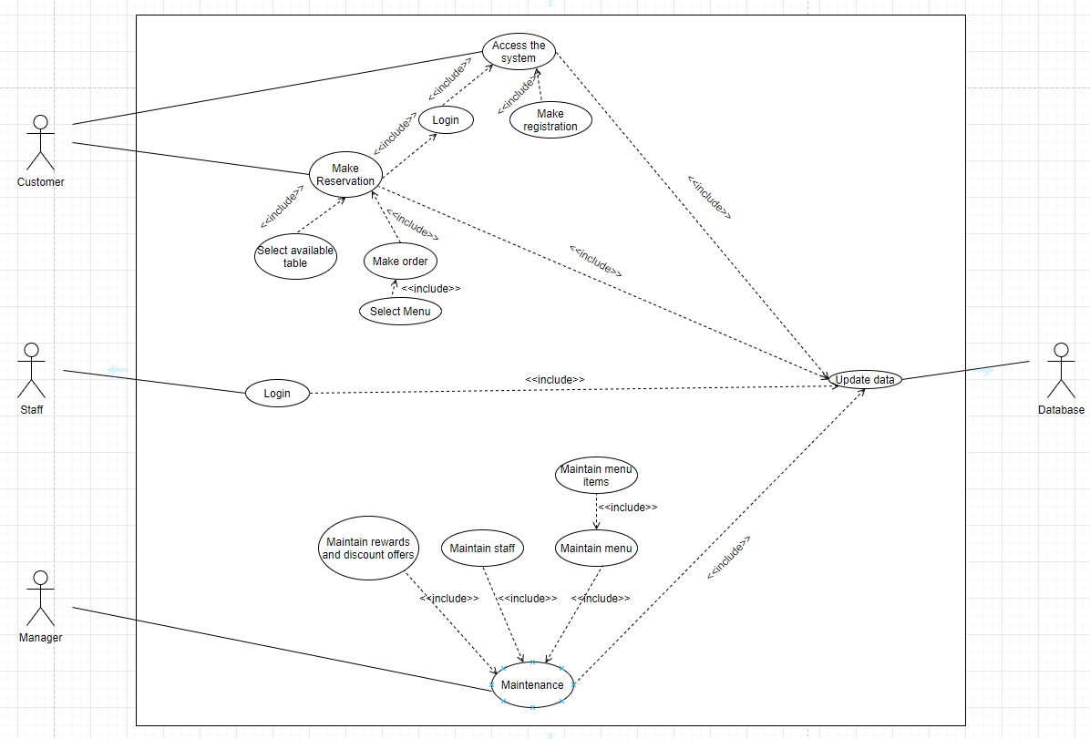

**Non-Functional Requirements (NRF’s)  - Zhihao Xing**

There are requirements that are not functional in nature. Specifically, these are the constraints the system must work within.

**Compatibility**

* The program and website should be compatibility with all major browsers and operation systems such as Windows, IOS and Android.

**User Interface**

* The UI should be designed user friendly and need to consider the color blindness users.

**Security**

* Access should be controlled with account name and password.
* Only staffs can access the staff mode and other customer users cannot.
* Database should be secured, and loss of information should be prevented.

**Performance**

* The system should be up and running 24/7.
* The system should support at least 100 users using the online booking concurrently without any lag.

**Backup and Recovery**

* Backup is needed to prevent loss of data and database are down。

**System Maintenance**

* System maintenance should be conducted base on regular interval.
* It should be conducted on off-peak time.

## Use Case Narratives (Iteration 1 / Sprint 1 only) - Ahmad

Use case narratives describe the process steps inside each use case. For each use case you will need

* A number and name that identify the use case. These are often assigned according to the organization’s standards, templates, and/or requirements processes.
* The pre-and post-conditions describe the scope of each use case. Since each use case begins and ends, we need to tell it where to begin and when to end.
* A matrix with what the actor does and how the system responds to each actor request. (scenario of each use case)
* Primary, alternate, and exception flows.

## Architecture Solution Options & Evaluation -2

Architecture used for Data and Application.

Application and Data architecture refers to how the organization's software applications are assembled as part of its overarching enterprise architecture and how those applications interact with each other to meet business or user requirements.

## Architecture Solution Model Diagram -1

A diagram of the chosen architecture solution for the project with how the different parts of the architecture are connected and related (See Canvas for an example).

3 levels of architecture required:

* Project
* Release
* Iteration

## Technology Stack, Proposed Solution -1 - Ahmad

A technology stack, also called a solutions stack, technology infrastructure, or a data ecosystem, is a list of all the technology services used to build and run one single application. For example you may have used something like or planned to use NodeJs with MongoDB with npm and other technology services to help you build your application.

## Contribution Table

|  |  |
| --- | --- |
| **Student Number** | **Completed Tasks** |
| 13623905, Andie | Release Backlog, Release & Iteration |
| 13924624, Chamod | Architecture Solution Options & Evaluation, Architecture Solution Model Diagram |
| 13421565, Zhihao | Use Case Model, Non-Functional Requirements |
| 14158226, Ahmad | Use Case Narratives, Technology Stack, Proposed Solution |
|  |  |
|  |  |